**DBMS Session 1**

**Assignment 1:**

1. **Ans**: Entities and attributes in storefront are

|  |  |
| --- | --- |
| **Entity** | **Relationship** |
| Product | product_id, product_name, product_description,category_id,product_price |
| Customer | customer_id, customer_name, customer_mobile, customer_email, customer_pswd |
| Category | category_id, category_name |
| Order | order_id, customer_id, order_date_time, order_amount, order_status, product_id,  payment_id |
| Address | customer_id,house_no, city, state, country, pincode |
| Admin | admin_username, admin_pw |
| Payment | order_id, payment_id, payment_method, payment_amount, payment_date |
| Image | img_id, img_name, product_id |

1. **Ans**: Relationship:

|  |  |  |
| --- | --- | --- |
| Entity | Relationship | Entity |
| Products(M) | Is In | Categories(M) |
| Order(M) | Contains | Products(M) |
| Customer(M) | has Placed | Order(M) |
| Admin(1) | Manage | Products(M) |
| Admin(1) | Manage | Customer(M) |
| Admin(1) | Manage | Categories(M) |
| Customer(1) | Has | Address(M) |

1. **Ans:** ER Diagram

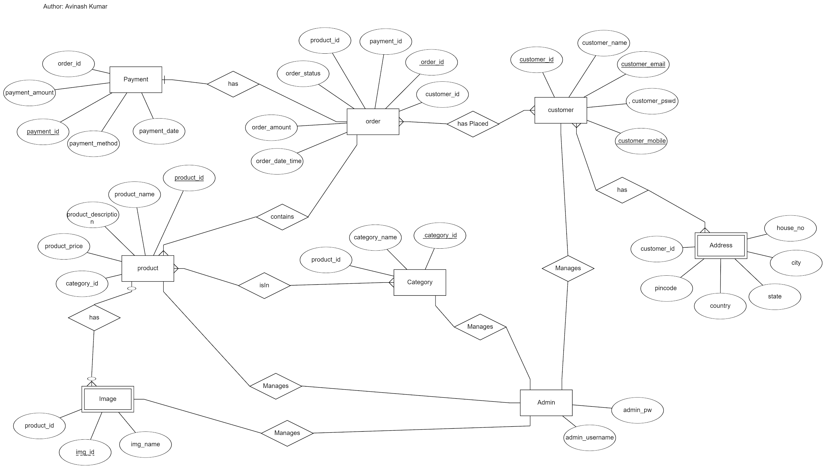

**Assignment 2: Normalization**

Normalization is a systematic approach of decomposing tables to eliminate data redundancy and undesirable characteristics like Insertion, Update and Deletion Anomalies.

* Normalization is used for mainly two purpose:
  + Eliminating redundant data.
  + Ensuring data dependencies make sense i.e data is logically stored.
* Normalization Rules:
  + 1st Normal Form
  + 2nd Normal Form
  + 3rd Normal Form
  + BCNF
* 1NF:
  + A relation will be 1NF if it contains an atomic value.
  + It states that an attribute of a table cannot hold multiple values. It must hold only a single-valued attribute.
  + First normal form disallows the multi-valued attribute, composite attribute, and their combinations.

Example: Given table violates 1NF as they contain multi valued attributes.

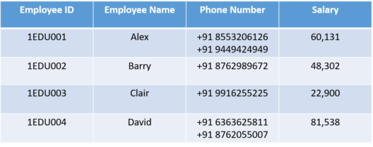

Above table in 1NF form:

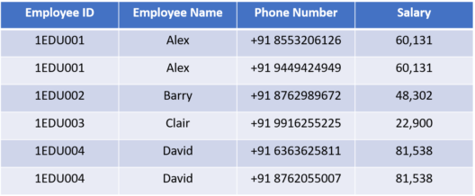

* 2NF :
  + In the 2NF, relational must be in 1NF.
  + In the second normal form, all non-key attributes are fully functional dependent on the primary key

Example: This table violates 2NF form as they contain partial dependency.

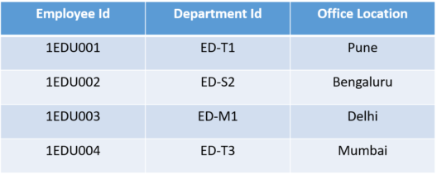

In 2NF form: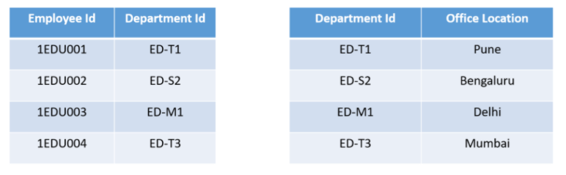

* 3NF :
  + A relation will be in 3NF if it is in 2NF and not contain any transitive partial dependency.
  + 3NF is used to reduce the data duplication. It is also used to achieve data integrity.
  + If there is no transitive dependency for non-prime attributes, then the relation must be in third normal form.

Example:

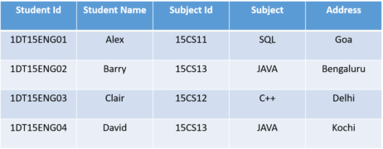

In 3NF form:

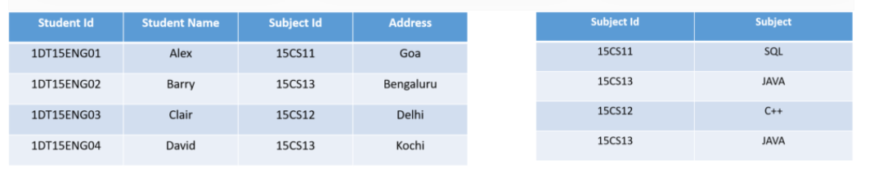

* BCNF:
  + BCNF is the advanced version of 3NF. It is stricter than 3NF.
  + A table is in BCNF if every functional dependency X → Y, X is the super key of the table.
  + For BCNF, the table should be in 3NF, and for every FD, LHS is super key.

Example:

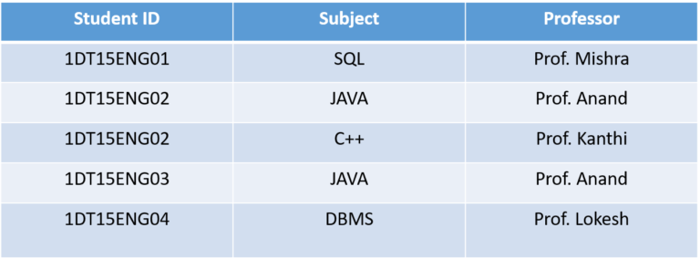

In BCNF form:

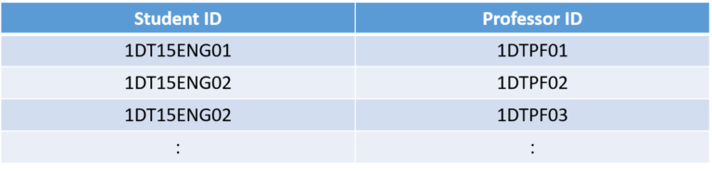

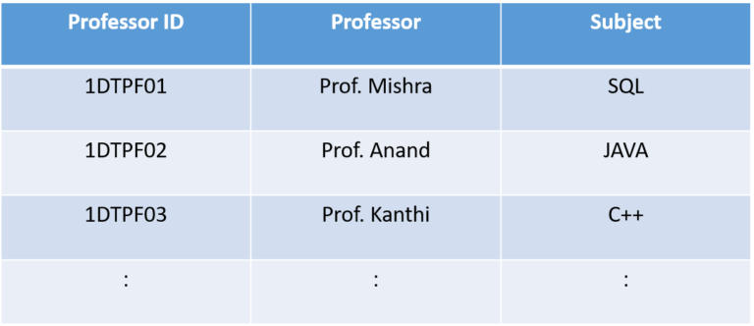

**Assignment 3:** Installation of mySQL

